**PRACTICAL 3**

**AIM:**

Write a smart contract of Election with following tasks:

a. Cast vote against two candidates

b. Vote should be cast only once.

c. No voter can vote any third candidate.

**CODE:**

pragma solidity 0.4.23;

contract Election {

struct Candidate{

uint id;

string name;

uint votecount;

}

mapping(address => bool) public voters;

mapping(uint => Candidate) public candidates;

uint public candidatesCount;

event votedEvent (

uint indexed_candidateId

);

constructor () public

{

addCandidates("BJP");

addCandidates("Congress");

}

function addCandidates(string _name) private {

candidatesCount++;

candidates[candidatesCount] = Candidate(candidatesCount, _name , 0);

}

function vote(uint _candidateId) public {

require(!voters[msg.sender]);

require(_candidateId> 0 && _candidateId<= candidatesCount);

voters[msg.sender] = true;

candidates[_candidateId].votecount++;

emit votedEvent(_candidateId);

}

}

**OUTPUT:**

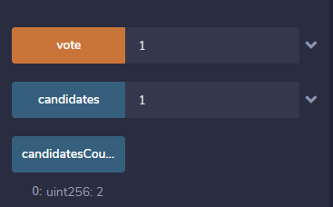

**CONCLUSION:**

In this practical, We learned about Smart Contract of Election.